Little Cog
Staging Our Futures
Producer
(Temporary Freelance Contract)

Application Pack

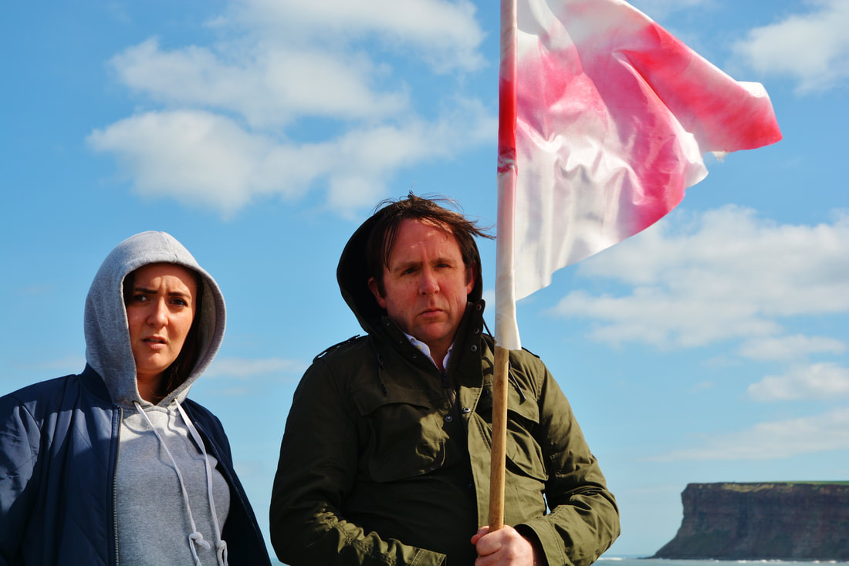

Image description - two actors, Philippa Cole and Simon Startin stand in the foreground looking to the camera. They are outdoors with a blue sky as the backdrop and in the distance is a cliff from the North East coast. The edge of the country. The photograph is from an early R&D for Another England. Simon is holding a hand made George's flag up.

Contents

Thank you for your interest in Little Cog and the Producer role we are currently advertising. We hope this pack contains all of the information you require but if you have any queries please don’t hesitate to contact Artistic Director, Vici Wreford-Sinnott at littlecog@rocketmail.com

- General information about the contract and fee
- A job summary
- Information about Little Cog and background context for Staging Our Futures
- Job Description
- Person Specification
- Access
- Definition of our use of the word disabled

How to apply

Once you have read the application pack and decided you’d like to apply please send us:
- A CV outlining producing experience with your key responsibilities and achievements, including contacts for 2 referees
- A two page letter describing and demonstrating, from your experience and professional practice, your suitability for the role using our person specification
- An Equality Monitoring Form

DEADLINE: Strictly 12 noon on Friday 17 July 2020

Interviews will take place via zoom or your preferred alternative the following week.

We’d like the successful applicant to be able to start as soon as possible after that.

Contract Duration and Fee

The contract offered is on a freelance basis lasting 15 days, spanning 4 months at a fee of £200 per day, a total of £3000 inclusive. Our ideal candidate will be able to commence the role as soon as possible.

Job Summary

Little Cog is seeking an experienced, pro-active and organised freelance producer to work alongside the Artistic Director to deliver our innovative, multi-strand Staging Our Futures programme. Staging Our Futures is a strategic artistic programme aiming to ensure Little Cog is involved as a key voice in theatre and arts planning as we move forward. It also consists of artist commissions, an in-house digital broadcast, and a series of disabled artist and disability equality masterclasses. There are responsibilities in organisational management, and fundraising. Little Cog is a disabled-led organisation, passionate about disabled peoples’ position in society, art and culture. Experience and knowledge of this area of work is essential.

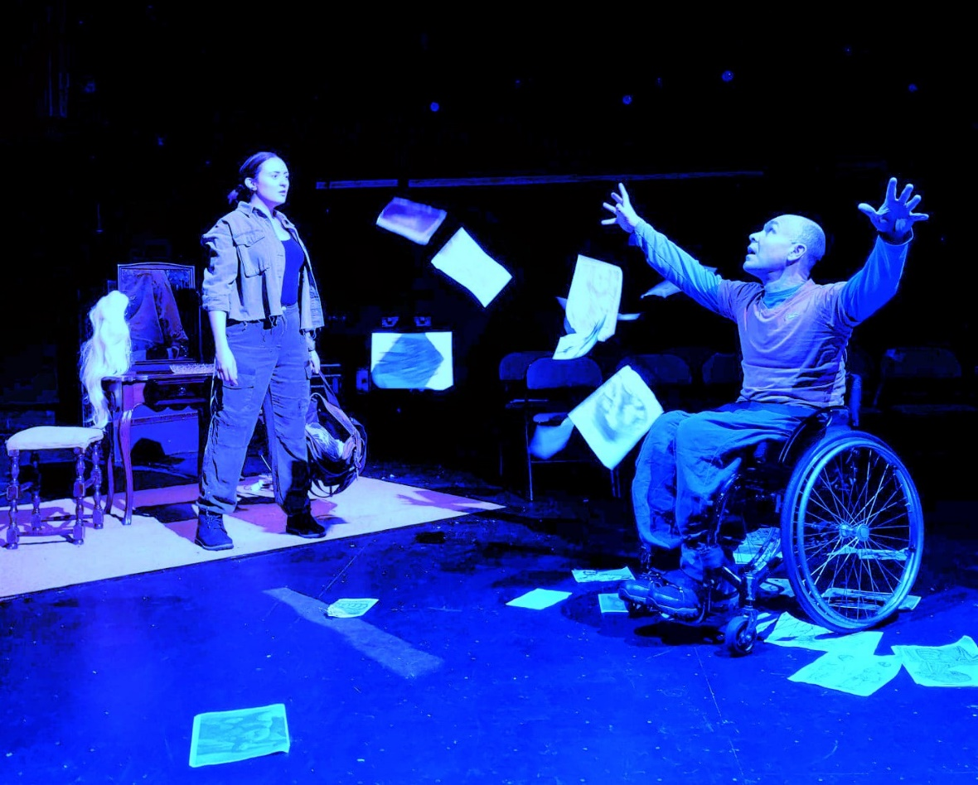
Image description – Actors Andrew McLay, who is a wheelchair user, and Philippa Cole playing Murphy and Rat in Another England. Murphy has thrown papers in the air and has his arms outstretched. Rat, standing at a dressing table, looks at him. Both are dressed in utilitarian costumes. The stage lighting casts a blue hue across the scene.

About Little Cog

Little Cog is an artistic catalyst for trailblazing disabled-led theatre based in the North East of England, which tours regionally and nationally. The company was founded by Artistic Director Vici Wreford-Sinnott in 2011. Vici is a leading figure in the national disability arts movement and disabled-led theatre sector, who has worked widely in the UK, Ireland and internationally.

Little Cog seeks to put the hidden stories and experiences of disabled** people centre-stage, whilst challenging entrenched historical and medical perceptions of disability and disabled people. We speak out about disabled peoples’ exclusion and the infringement of our human and civil rights, as we believe in the right of every person to be at the centre of the nation’s cultural life.

Image description – actor Jacqueline Phillips, with blond spiky hair, and wearing a grey linen top and black trousers, plays Beatrice in Butterfly. She is perched on a large table in front of a projection of cogs and equations. A BSL interpreter is in the background.

We explore and celebrate an extraordinary social phenomenon, with a rich cultural and social history, with phenomenally talented disabled theatre actors, writers, artists, designers, thinkers and practitioners who create cutting edge, vital and valid work. Work which is beautiful, powerful, witty and challenging work. We explode the stage with new protagonists, new narratives and new or forgotten stories.

We are proud to be based at ARC Stockton, with whom we have an innovative longstanding partnership and where we have created influential models of practice. We work with sincere allies to create more accessible environments for disabled artists where are voices are valued and equal.

Little Cog actively advocates for change in how art and culture are organized, and the inherent hierarchies of power at play.

Background
The Little Cog Staging Our Futures project is possible from an emergency response award from Arts Council England, where we will focus on stabilising our organisation, positioning the company as a leading advocate voice for disability equality in the North East, and nationally, delivering three artistic commissions and an artistic piece of our own. We’ll also be offering online masterclasses for disabled artists.

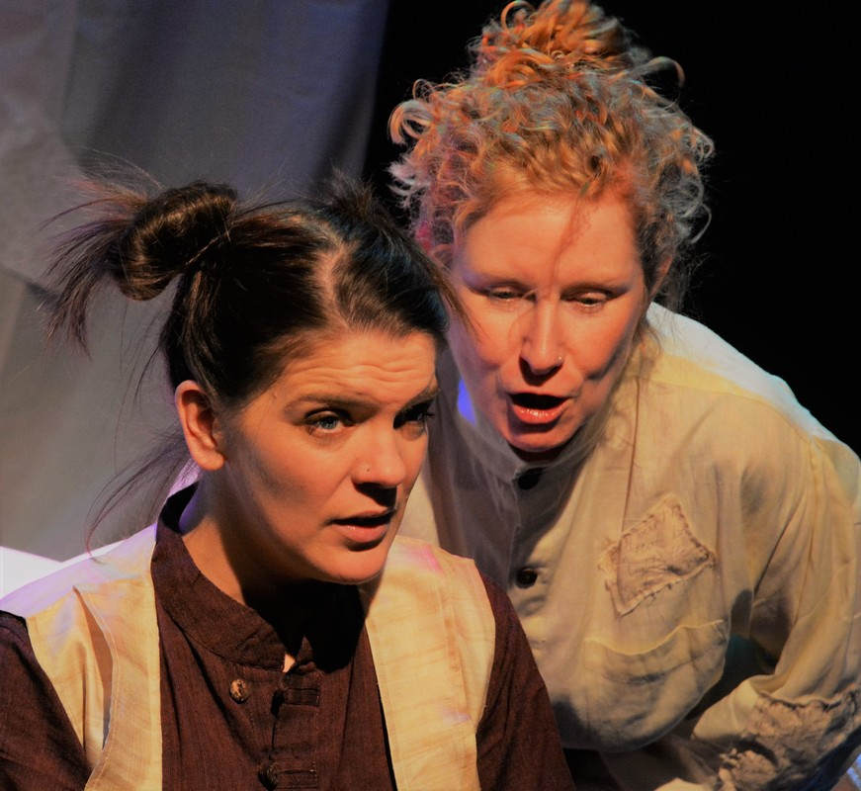

Image description – Coll Metcalfe and Jennifer Lisky play Mona and Pip in Lighthouse. Mona, with her hair up in a bun, is leaning over a seated Pip, looking harsh. Pip looks worried at what Mona is saying.

Job Description
- Collaborate with the Artistic Director to raise the profile of Little Cog, our achievements, our artistic work and our expertise regionally and nationally, and particularly our role in important conversations taking place about theatre recovery.
- Support the Artistic Director in forging and maintaining new and existing relationships with key partners & stakeholders
- Create project management plans, streamlined schedules and effective record keeping systems that make best use of time and resources across all aspects of Staging Our Futures including commissions, digital production, participation, rehearsals and public communications
- Plan, manage and oversee commissions and the disabled artist and disability equality masterclass programme
- Create ideas and opportunities for promoting the core messages and work of the company on our website, social media, media and blog articles
- Prepare and distribute key papers, contracts, itineraries for projects
- Create a database of key contacts including stakeholders / artists / venues / policy makers / press and distribute marketing and promotional materials when relevant
- Project manage stakeholder events/ openings/ press opportunities
- Develop innovative ways to evaluate and share our impact
- Be aware of and contribute to applications for new funding opportunities from a diverse range of sources for project-specific grants, ongoing core costs and company growth

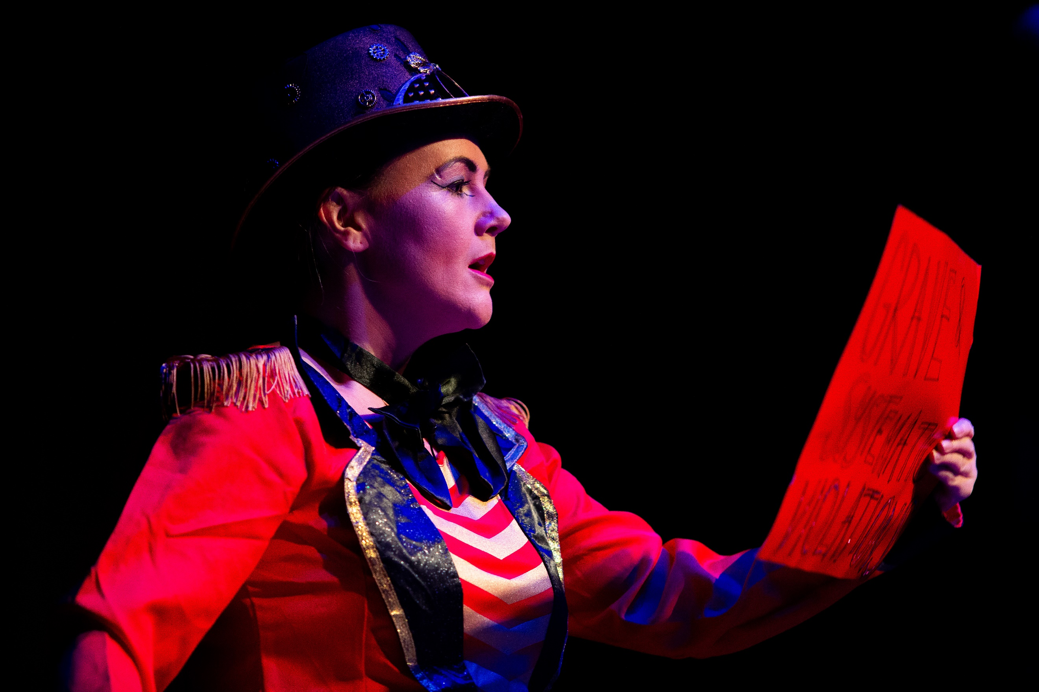
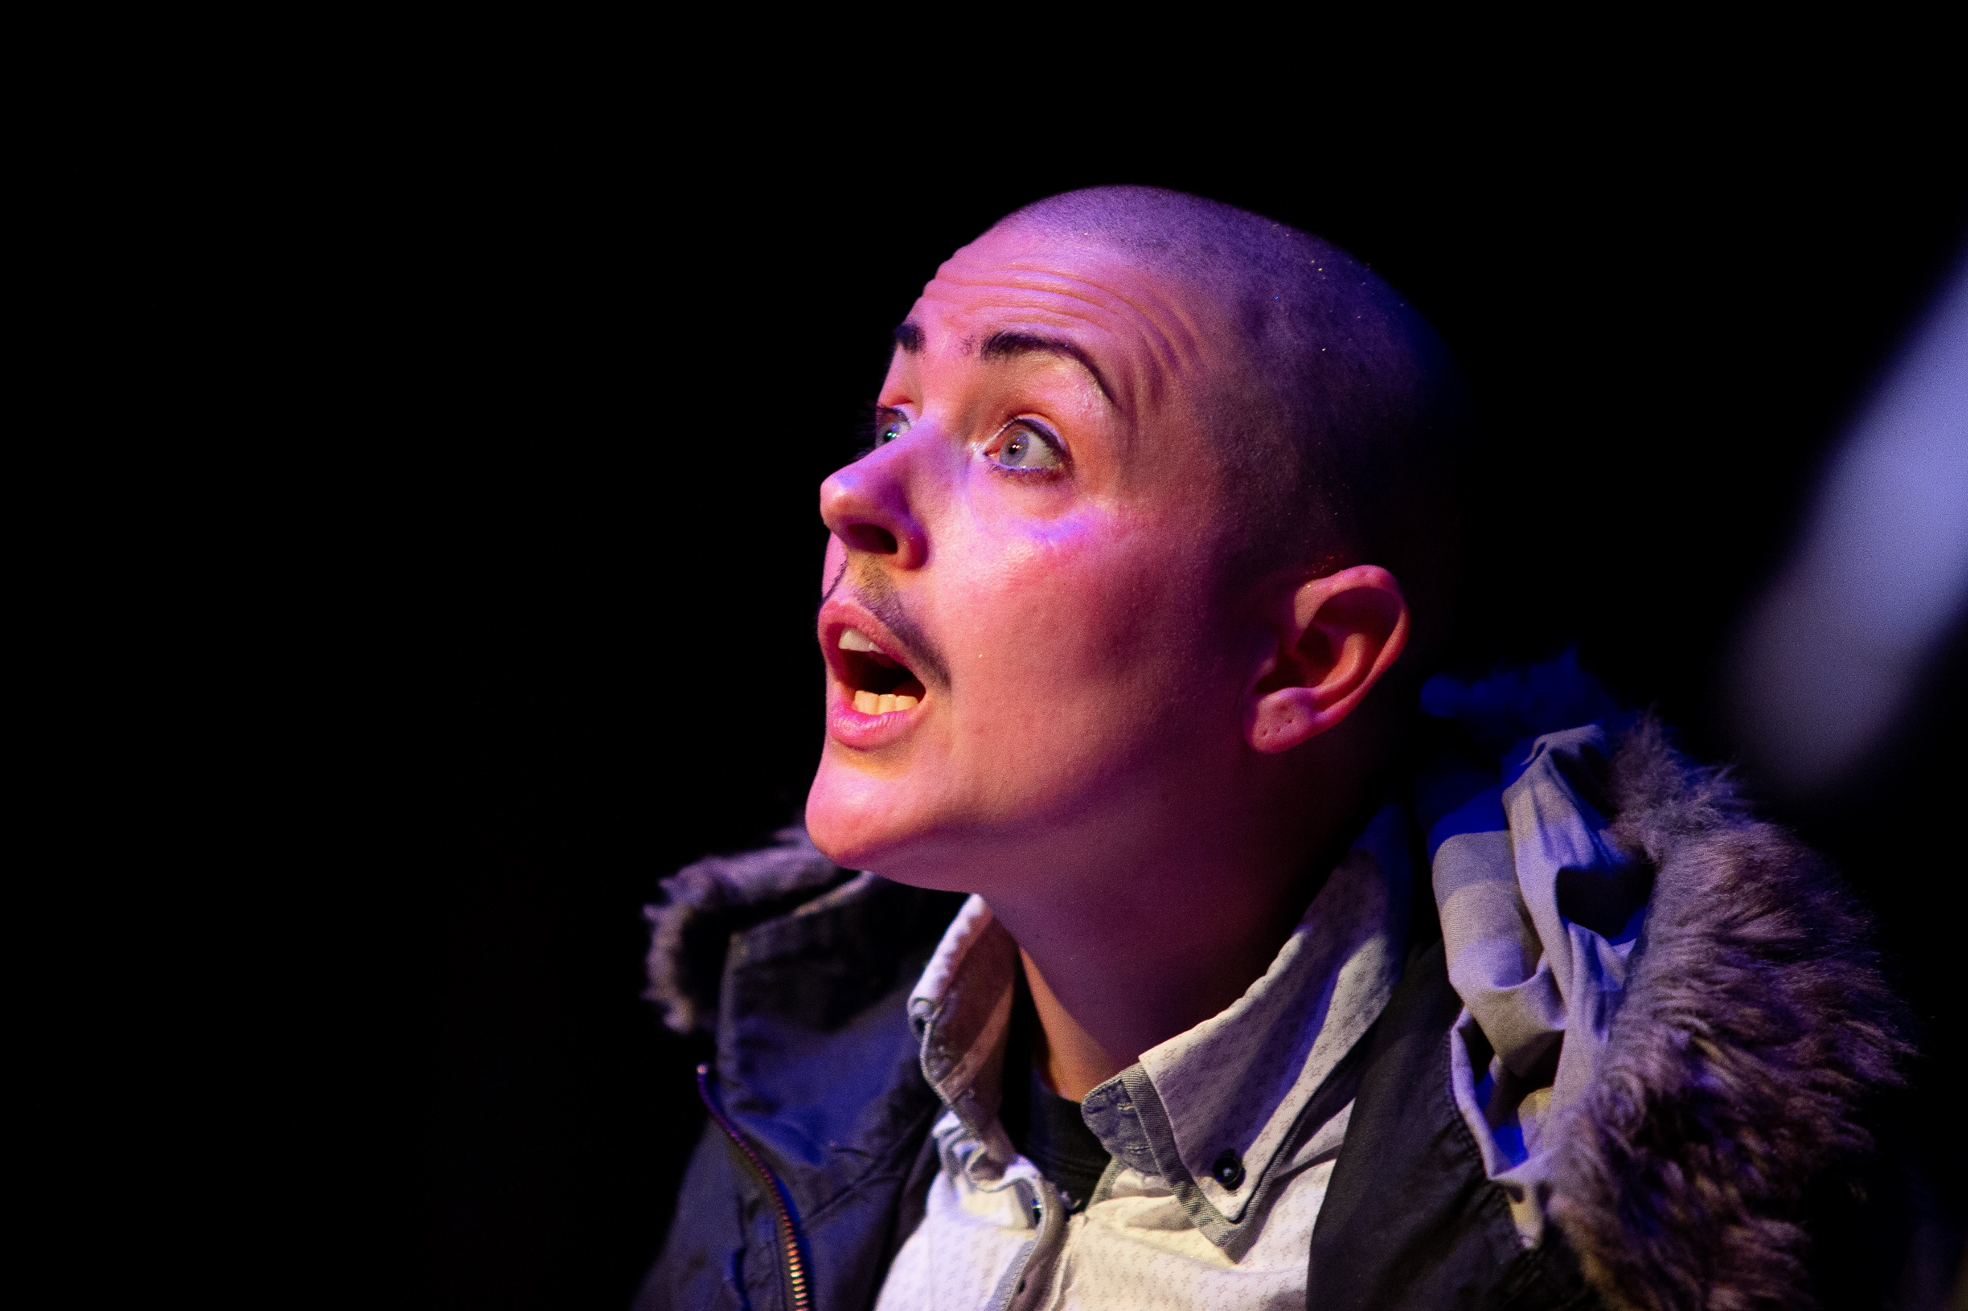

Image description - Lisette Auton is performing as Crip Mistress in full bright red ringmaster costume and hat. She is holding a red piece of paper and is in fierce spoken word flow. Disconsortia DIY Cabaret. Photo Credit Kev Howard
Image description - King Kitt is performing a lip sync, looking up questioningly. They are wearing a fur-trimmed hooded parka and drag make up consisting of a moustache and darkened eyebrows.
Disconsortia DIY Cabaret. Photo Credit Kev Howard

Person Specification
- Ability to forge strong lasting partnerships across the arts and theatre sectors
- Passionate about disabled-led theatre, and more broadly diversity and social justice in the arts, with an understanding of both the challenges it is facing and its potential to change the cultural landscape
- Bring a knowledge of, and ensure that Little Cog is involved and at the forefront of, discussions about recovery from the Covid-19 lockdown, regionally and nationally
- Ability to recognise new partnership and strategic opportunities for Little Cog
- Three years experience working in a producing capacity
- Excellent collaboration and communication skills, setting and working to agreed timelines
- Have a positive, open and honest approach
- A commitment to creating an accessible working environment for all involved in our work
- A knowledge of the current fundraising landscape
- Have a broad view of communications opportunities to promote the company
- Rigorous organisational and multi-tasking skills with attention to detail
- Working knowledge of providing information and artwork in a range of accessible formats
- A knowledge and awareness of Little Cog’s work and role in the arts sector

Access
We aim to ensure our work is as accessible as possible and to promote good practice to all we work with. If you are a disabled person making this application, we are assuming that you have access support in place as a freelancer from Access to Work, however if this is not the case please do get in touch to discuss this further. Email Vici Wreford-Sinnott at littlecog@rocketmail.com

**Definition of disabled
We work to the social model of disability which says that society disables people through its poor and unequal services, through systemic barriers and prejudices, and through the attitudinal, physical, psychological, sensory and neurotypical obstacles in all areas of life.
The umbrella of disability generally includes a very wide range of conditions, sometimes referred to as impairments, as long term health problems, mental health, chronic health conditions, neurodivergence, sensory conditions including being a blind or visually impaired person or a D/deaf or hearing impaired person, and learning disabled people. Our current overview includes anyone who may be either discriminated against or excluded on the basis of such a condition.
We understand that the term disability has traditionally been regarded as a negative term because it has been medically and economically loaded with descriptions around deficit. We challenge those narratives and reclaim the term disabled as a political act to describe the inequality we experience. The deficits lie in society and the way it is organised.
We describe ourselves as a disabled-led theatre company working with disabled artists. However, we completely respect however you choose to describe yourself and would only use terminology you are comfortable with in descriptions of yourself.

Don’t hesitate to ask if you have any questions.

We look forward to receiving your application. Thank you

